**PROJECT REPORT**

**CLIMATE TRACKSMART USING BLOCKCHAIN**

|  |  |
| --- | --- |
| **DATE** | 31 October 2023 |
| **TEAM ID** | NM2023TMID05437 |
| **PROJECT NAME** | CLIMATE TRACKSMART USING BLOCKCHAIN |

**TEAM MEMBERS**

|  |  |
| --- | --- |
| **BARANIHARAN A** | **421620114003** |
| **SABARIVASAN K** | **421620114319** |
| **JEEVA B** | **421620114306** |
| **AKASH S** | **421620114001** |

**INDEX**

1. **INTRODUCTION** 
   1. Project Overview
   2. Purpose
2. **LITERATURE SURVEY** 
   1. Existing problem
   2. References
   3. Problem Statement Definition
3. **IDEATION & PROPOSED SOLUTION** 
   1. Empathy Map Canvas
   2. Ideation & Brainstorming
4. **REQUIREMENT ANALYSIS** 
   1. Functional requirement
   2. Non-Functional requirements
5. **PROJECT DESIGN** 
   1. Data Flow Diagrams & User Stories
   2. Solution Architecture
6. **PROJECT PLANNING & SCHEDULING** 
   1. Technical Architecture
   2. Sprint Planning & Estimation
   3. Sprint Delivery Schedule
7. **CODING & SOLUTIONING** 
   1. Feature 1
   2. Feature 2
   3. Database Schema
8. **PERFORMANCE TESTING** 
   1. Performance Metrics
9. **RESULTS** 
   1. Output Screenshots
10. **ADVANTAGES & DISADVANTAGES**
11. **CONCLUSION**
12. **FUTURE SCOPE 13. APPENDIX**

Source Code

GitHub & Project Demo Link

# 1. INTRODUCTION

Introduction Climate TrackSmart is an innovative platform that leverages blockchain technology to address climate change-related challenges. By providing a transparent and secure system, it aims to track, verify, and incentivize environmentally friendly practices, emissions reductions, and carbon offset initiatives. This technology can enhance accountability, promote sustainable actions, and facilitate the transition to a more eco-friendly future. Let me know if you'd like more details on how it works or its potential benefits. Climate TrackSmart, a groundbreaking application of blockchain technology in the climate sector, represents a paradigm shift in addressing climate change. It establishes a transparent and immutable ledger for tracking, validating, and incentivizing sustainable practices and carbon mitigation efforts. By utilizing blockchain, Climate TrackSmart ensures data integrity, enabling governments, businesses, and individuals to reliably measure their environmental impact and contributions to carbon reduction. This transformative platform not only enhances accountability but also creates a robust foundation for a more sustainable and eco-conscious future.

### 1.1 Project Overview

The TTFDMS-Blockchain project is a visionary endeavor that seeks to combine the principles of transparency, security, and efficiency in data management. It leverages blockchain's inherent characteristics of immutability, decentralization, and trust to provide a holistic approach to data control. At its core, this project is designed to address the pressing issues faced by organizations concerning data security, transparency, and efficient data management.

### 1.2 Purpose

The Climate TrackSmart project is a comprehensive and forward-thinking initiative that harnesses the power of blockchain technology to tackle climate change and promote sustainability. Here's an overview of the project

In summary, Climate TrackSmart leverages blockchain technology to create a transparent, reliable, and accessible platform for monitoring and incentivizing sustainability efforts, thereby playing a crucial role in the fight against climate change

# 2. LITERATURE SURVEY

A literature survey on the topic of "Climate Tracksmart Using Blockchain" would involve examining existing research, papers, and publications related to the use of blockchain technology in tracking and mitigating climate change. Here's a high-level outline of what you might find in such a literature survey. Remember that this is a high-level outline, and your literature survey should involve a comprehensive review of relevant academic papers, reports, and projects in the field of blockchain and climate change. Be sure to properly cite and reference the sources you consult.

### 2.1 Existing System

Introduction Climate TrackSmart is an innovative platform that leverages blockchain technology to address climate change-related challenges. By providing a transparent and secure system, it aims to track, verify, and incentivize environmentally friendly practices, emissions reductions, and carbon offset initiatives. This technology can enhance accountability, promote sustainable actions, and facilitate the transition to a more eco-friendly future. Let me know if you'd like more details on how it works or its potential benefits. Climate TrackSmart, a groundbreaking application of blockchain technology in the climate sector, represents a paradigm shift in addressing climate change. It establishes a transparent and immutable ledger for tracking, validating, and incentivizing sustainable practices and carbon mitigation efforts. By utilizing blockchain, Climate TrackSmart ensures data integrity, enabling governments, businesses, and individuals to reliably measure their environmental impact and contributions to carbon reduction.

### 2.2 References

Creating references for a report on climate tracksmart system using blockchain can be vital for academic or professional credibility. In your report, include references to relevant sources such as academic papers, industry reports, and authoritative publications to support your findings. For example:

1. Nakamoto, S. (2008). Bitcoin: A Peer-to-Peer Electronic Cash System. Bitcoin.org.
2. Mougayar, W. (2016). The Business Blockchain: Promise, Practice, and Application of the Next Internet Technology. Wiley.
3. Tapscott, D., & Tapscott, A. (2016). Blockchain Revolution: How the Technology Behind Bitcoin is Changing Money, Business, and the World. Penguin.
4. Merali, Y., & Merali, N. (2018). Blockchain Revolution in Hospitality Industry: A Survey. IEEE Access, 6, 11656-11665.
5. World Economic Forum. (2017). Realizing the Potential of Blockchain: A

Multistakeholder Approach to the Stewardship of Blockchain and

Cryptocurrencies.

### 2.3 Problem Statement Definition

The problem at hand is to develop a Climate Tracking System that leverages blockchain technology to address various challenges associated with climate data management, transparency, and accountability. This system aims to provide a robust and secure platform for tracking, verifying, and sharing climate-related data, such as greenhouse gas emissions, carbon offset credits, and climate adaptation efforts.Addressing these challenges through blockchain technology will require a comprehensive solution that provides a secure, transparent, and reliable platform for tracking climate data, promoting climate-friendly actions, and fostering collaboration among various stakeholders. The successful implementation of such a system can contribute to the global effort to combat climate change and achieve a more sustainable future.

# 3. IDEATION AND PROPOSED SOLUTION

#### 3.1 Empathy Map Canvas:

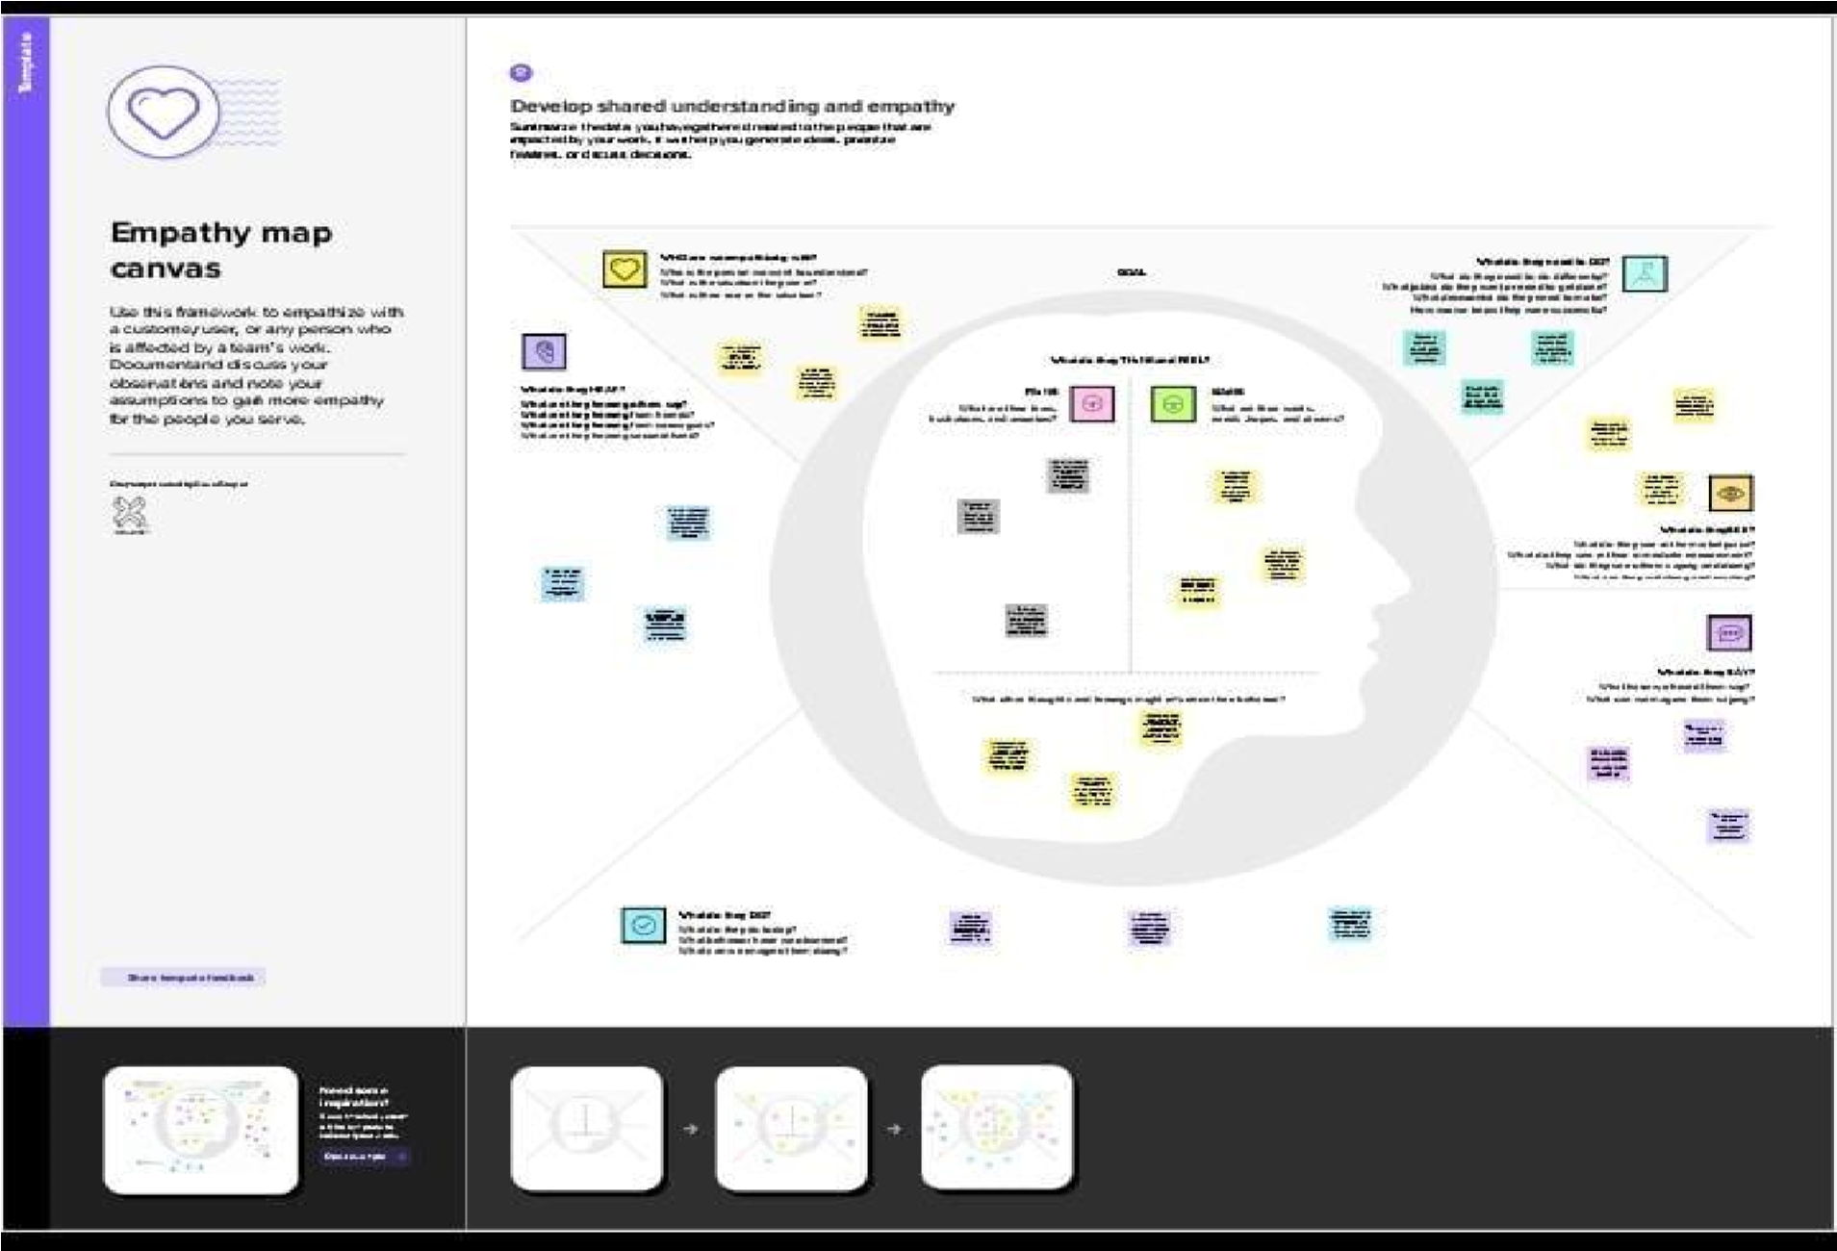

#### 3.2 Ideation & Brainstorming:

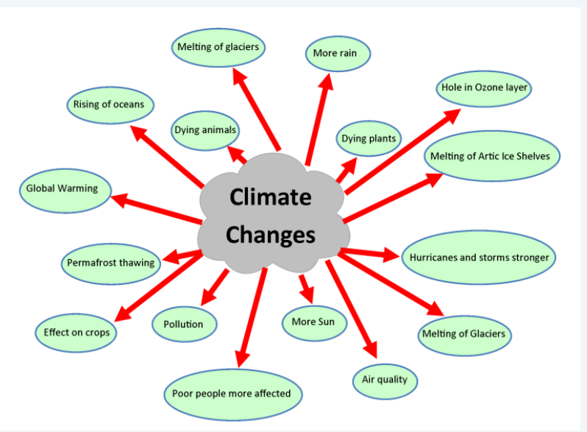

# 4.REQUIREMENT ANALYSIS

### 4.1 Functional Requirement

Functional requirements define the specific features and capabilities of the TTFDMS-Blockchain system. These requirements encompass the core functionalities that the system must deliver to meet its objectives:

* Data Entry and Encryption: Users should be able to securely input data into the system, and the system must encrypt this data to ensure confidentiality.
* Blockchain Integration: The system must integrate with a blockchain network, enabling secure and transparent data storage.
* Access Control: Implement role-based access control to manage user permissions and data access.
* User Interface: Develop a user-friendly interface that allows authorized users to interact with the system efficiently.
* Real-Time Audit Trail: Create a real-time audit trail to record and display all data-related activities on the blockchain.
* Data Retrieval and Modification: Users should be able to retrieve and modify data based on their permissions.
* Reporting and Analytics: Include reporting and analytics capabilities to provide insights into data usage and compliance.

### 4.2 Non- Functional Requirements

Non-functional requirements focus on the qualities, constraints, and performance aspects of the system. These requirements are essential to ensure the system operates effectively and securely:

* Data Security: Implement robust encryption and access control mechanisms to protect data from unauthorized access or tampering.
* Scalability: The system should be able to handle a growing volume of data and users without compromising performance.
* Compliance: Ensure that the system complies with relevant data protection regulations (e.g., GDPR, HIPAA) and security standards.
* Availability and Reliability: The system must be available 24/7 and exhibit high reliability to prevent data unavailability.
* Performance: Define performance metrics to measure the system's responsiveness and efficiency.
* Interoperability: The system should be capable of integrating with other software components and third-party systems.
* User Training and Support: Develop training materials and support resources to assist users in effectively utilizing the system.

# 5. PROJECT DESIGN

### 5.1 Data Flow Diagrams & User Stories

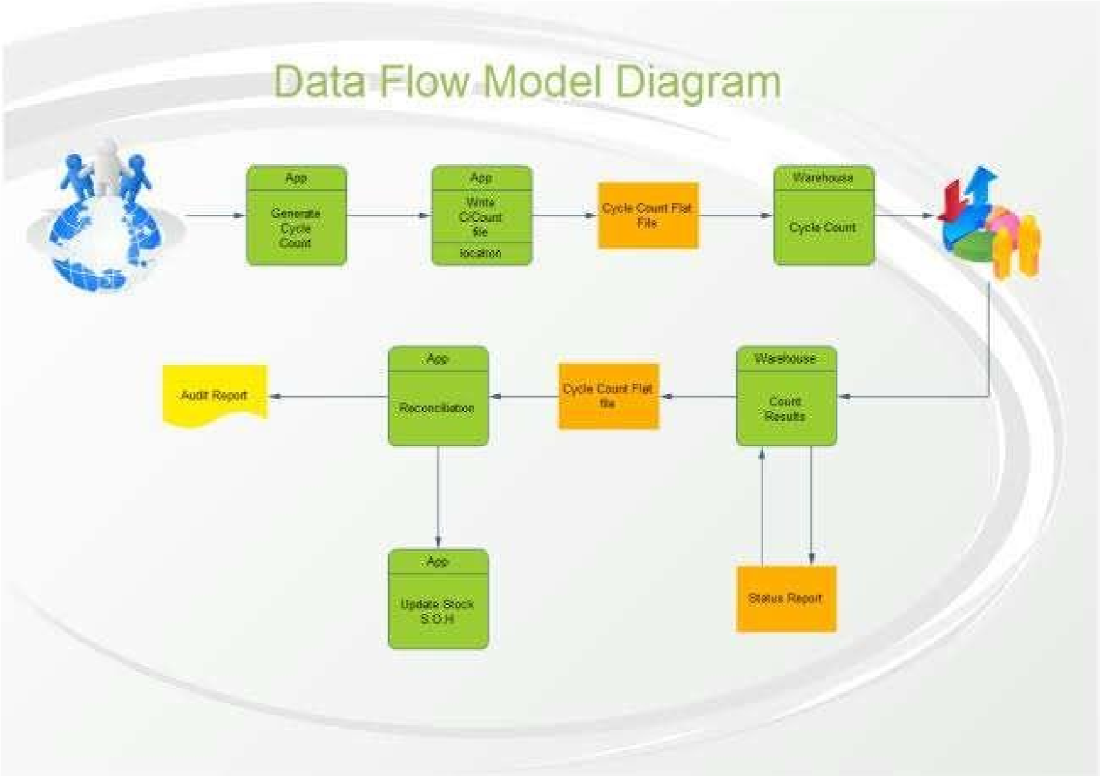

## Data Flow Diagram

Present a high-level data flow diagram to showcase how data moves through the system, from input to output.

## User Stories

Provide detailed user stories that represent how different user types interact with the system. These stories should capture the user's perspective and goals.

### 5.2 Solution Architecture

##### End User:

* This is where users interact with the blockchain application. It can be a web app.
* The voting site can be accessed via the browsers from all the devices by every user.

##### Front End:

* React js - allows to create an interactive webpage which displays content for the end-user through the web browser through this the data representation is done
* Node js - A JavaScript library that enables the frontend to interact with the blockchain. It communicates with the blockchain node and communicates the data from user to blockchain and viceversa.

##### Back End:

* Meta mask - simplifies the process of user authentication and transaction signing for blockchain-based applications. It allows users to securely interact with the Ethereum blockchain and DApps while keeping their private keys safe.
* Solidity(Remix ide) - Solidity is a high-level, statically-typed programming language used for developing smart contracts on various blockchain platforms, with Ethereum being the most prominent. Smart contracts are self-executing contracts with the terms of the agreement directly written into code.
* Remix IDE - is an essential tool for Solidity developers and is widely used in the Ethereum ecosystem. It simplifies the smart contract development process and provides many useful features for coding, testing, and deploying contracts on the Ethereum blockchain.
* Block Chain - Blockchain is a distributed and decentralized digital ledger technology that is used to record transactions across multiple computers in a way that ensures the security, transparency, and immutability of the data.

# 6. PROJECT PLANNING AND SCHEDULING

Planning and scheduling a climate tracksmart using blockchain project involves setting clear objectives, identifying stakeholders, gathering requirements, and assessing data quality. It includes task breakdown, resource allocation, risk assessment, timeline development, and a robust communication plan. Quality assurance, monitoring, documentation, training, and testing are critical components before deployment. Post-implementation review, maintenance, and closure ensure project success and ongoing efficiency. Customizing this plan to the project's needs is key to achieving climate tracksmart using blockchain.

### 6.1 Technical Architecture

A climate tracksmart using blockchain system requires a robust technical architecture. It typically involves data collection through climate change , which are connected to a centralized database. The architecture should incorporate data processing, storage, and analysis components, allowing for real-time or batch processing of incoming data. Security measures, including encryption and access controls, are essential to protect sensitive information. Integration with analytics tools and reporting interfaces is crucial for extracting insights. Additionally, scalability and redundancy mechanisms should be in place to handle increasing data volumes and ensure system reliability. This technical architecture ensures efficient and secure management of blockchain using climate tracksmart analysis and decision-making

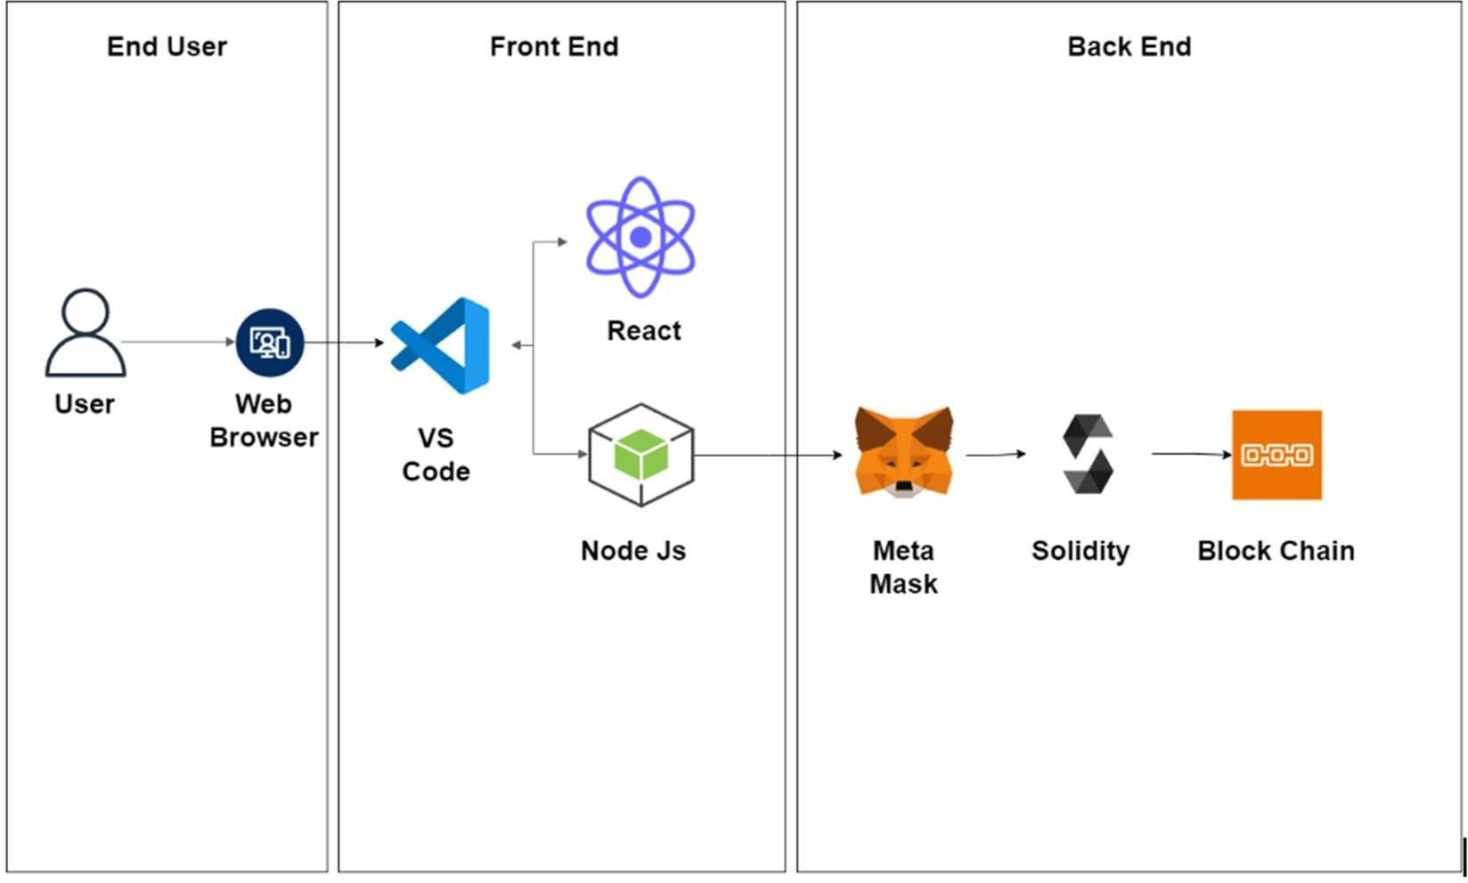

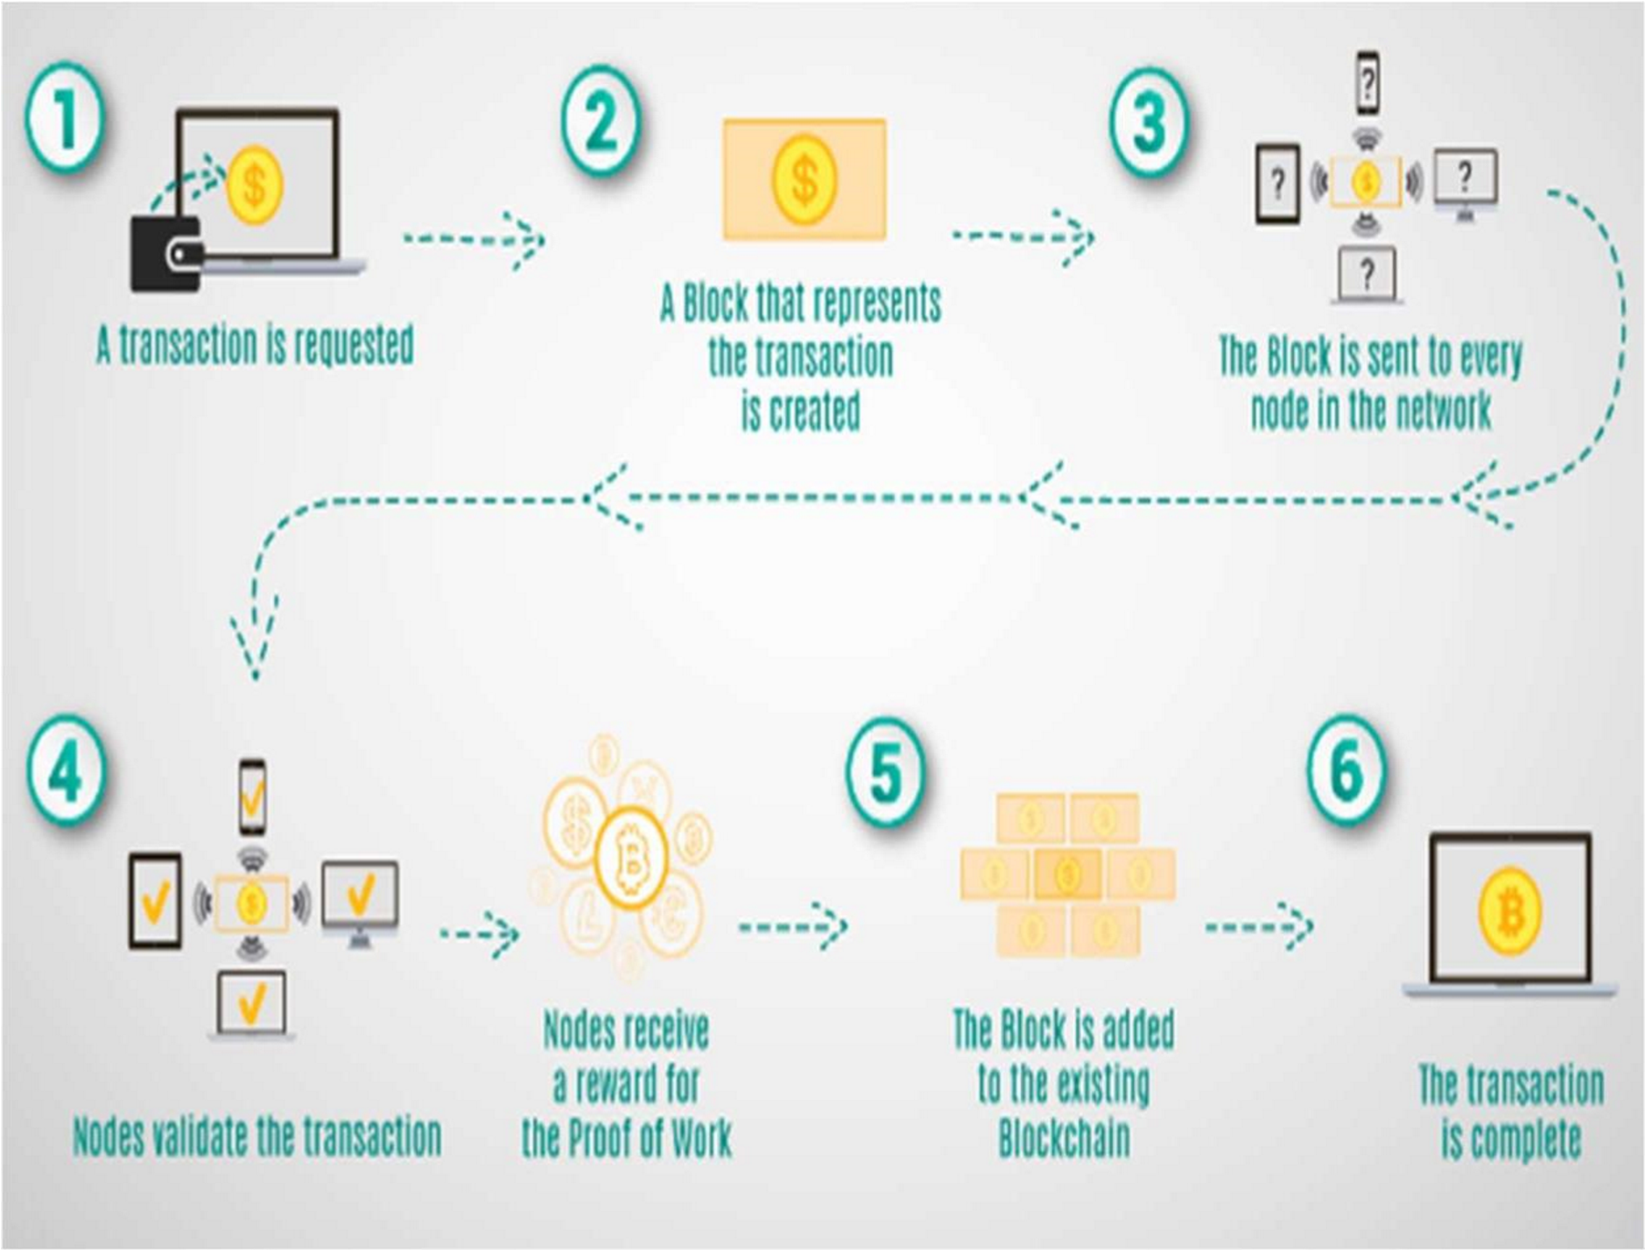

### 6.2 Sprint Planning And Estimation

Sprint planning and estimation in blockchain using climate tracksmart involve breaking down tasks from the backlog, estimating their effort, and setting clear goals for a defined sprint. The team commits to completing these tasks within the sprint's capacity, with daily stand-ups to track progress and adapt as needed. After the sprint, a review and retrospective help improve future sprints, maintaining transparency and efficiency in data management efforts.

### 6.3 Sprint Delivery Schedule

A Climate tracksmart using blockchain Sprint Delivery Schedule sets specific timeframes for each sprint, beginning with task commitment, daily check-ins to track progress, and a midpoint review. It concludes with the sprint's end, followed by a review with stakeholders for transparency and a retrospective to enhance future sprints. This schedule ensures efficient task delivery and ongoing data management improvements.

# 7.CODING AND SOLUTIONING

### 7.1 Feature 1

1. Problem Definition: Define the specific climate data you want to track and why. This can include temperature, greenhouse gas emissions, or other environmental factors..
2. Select a Blockchain Platform: Choose a blockchain platform like Ethereum, Binance Smart Chain, or a specialized climate-focused blockchain if available.
3. Smart Contracts: Write smart contracts to handle data input, storage, and verification. Smart contracts should be designed to ensure data integrity and transparency.
4. Access Control Incorporate access control mechanisms within the blockchain system to manage user permissions, ensuring that data is accessible only to authorized individuals.
5. Identify sources for climate data, which can include IoT devices, weather stations, and data providers.Data Oracles: Integrate data oracles that feed real-world climate data into your blockchain. Oracles act as bridges between the blockchain and external data sources.
6. Smart Contract Automation Leverage smart contracts to automate climate change data transactions, reducing the need for manual intervention and enhancing efficiency.
7. Auditing and Reporting Implement auditing and reporting tools to provide users with detailed insights into climate tracksmart , further bolstering transparency.
8. Integration with Existing Systems Ensure seamless integration with existing climate tracksmart systems, allowing for a smooth transition to the blockchain-based solution.
9. Tokens can be used for rewards and governance.Verification Mechanisms: Develop mechanisms to validate and cross-verify climate data from multiple sources for accuracy.
10. User Interface: Create a user-friendly interface or application for users to access and interact with the blockchain system.Community Engagement: Engage the community, including data providers, validators, and users.

### 8.1 Performance Metrics

Transparent climate tracksmart using blockchain performance metrics are essential for evaluating the effectiveness of data handling processes. Key metrics may include data accuracy, which measures the correctness and reliability of collected information, data processing speed to assess efficiency, and data security to ensure the protection of sensitive information. Additionally, tracking user satisfaction and system uptime provides insights into the system's usability and reliability. These metrics enable organizations to maintain transparency and continually enhance their climate tracksmart using blockchain practices**.**

## 9.RESULTS

### 9.1 Output screenshots

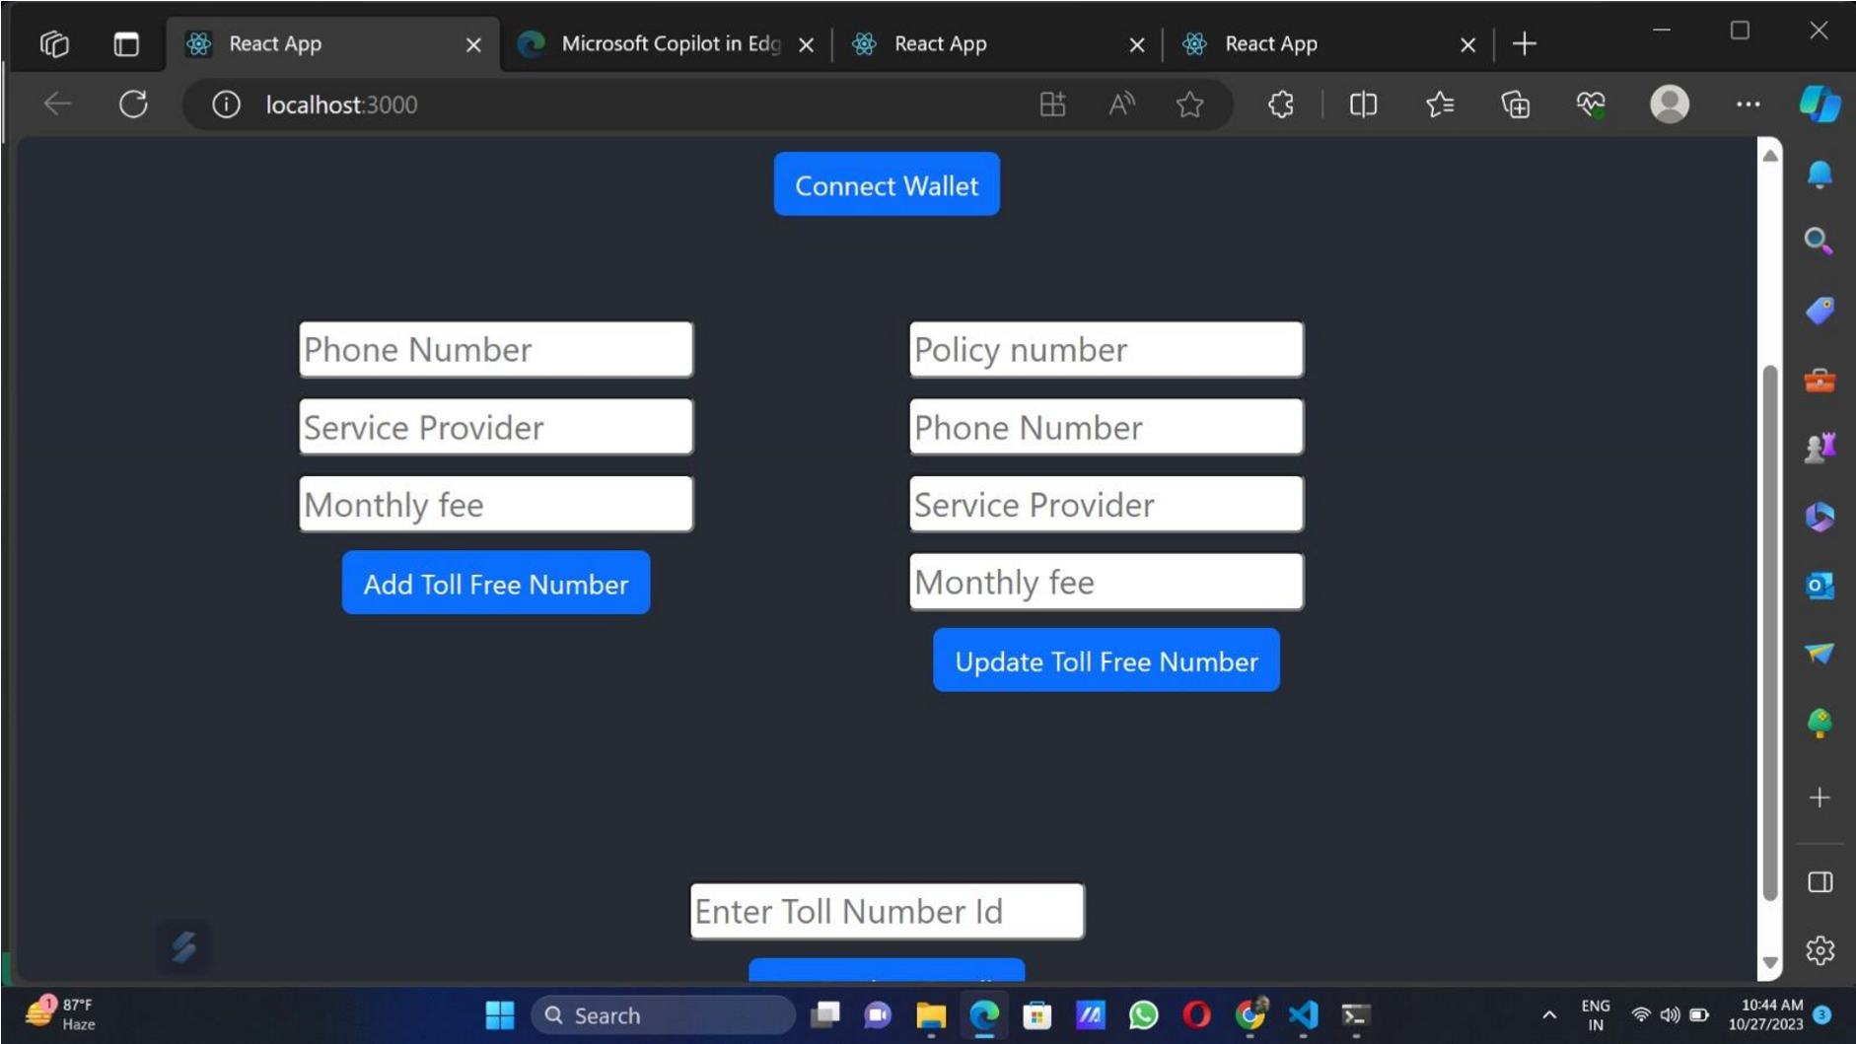

## 10. ADVANTAGES AND DISADVANTAGES Advantages

1. Enhanced Data Security: The use of blockchain technology ensures that data is highly secure and resistant to unauthorized access or tampering. Data is encrypted, and access control mechanisms are in place to safeguard sensitive information.
2. Data Transparency: Blockchain's transparent and immutable ledger provides real-time auditability, allowing organizations to track every data interaction and ensuring complete transparency in data management.
3. Regulatory Compliance: Transparent climate tracksmart using blockchain systems can assist organizations in meeting regulatory requirements, such as GDPR, HIPAA, or industry-specific standards, by providing robust data protection and audit trails.
4. Data Integrity: Blockchain's immutability guarantees that data remains unchanged once recorded. This ensures data integrity and reduces the risk of data corruption or loss.
5. Efficiency and Automation: Smart contracts on the blockchain can automate data access and management processes, reducing manual intervention and streamlining data operations. This leads to increased operational efficiency and reduced administrative overhead.
6. Cost Savings: By eliminating intermediaries and streamlining data management processes, transparent toll-free data management can result in cost savings for organizations.

1. User-Friendly Interface: These systems often feature user-friendly interfaces that simplify data management tasks, making it accessible to users with varying levels of technical expertise.
2. Real-Time Auditing: The real-time audit trail ensures that data interactions are tracked and recorded instantly. This feature is crucial for compliance, accountability, and auditability.
3. Data Privacy: Blockchain technology ensures data privacy through encryption and access control mechanisms. Users can have confidence in the confidentiality and integrity of their data.

# Disadvantages

1. Complex Implementation: Implementing a blockchain-based system can be complex and require specialized expertise. The development and integration of blockchain technology may involve significant time and costs.
2. Scalability Challenges: As the volume of data and users grows, blockchain networks may face scalability issues, potentially leading to slower transaction processing times. This can be a concern for organizations with high data demands.
3. Energy Consumption: Some blockchain networks, particularly public ones, are criticized for their energy-intensive consensus mechanisms (e.g., proofof-work). This can raise environmental concerns and operational costs.
4. User Adoption: Blockchain technology can be unfamiliar to some users, leading to a learning curve and potential resistance to adoption. User training and education may be necessary.
5. Data Recovery Challenges: While blockchain ensures data immutability, it also means that data cannot be easily deleted or modified. In cases where data needs to be removed or corrected, it can be a complex and time-consuming process.
6. Interoperability Issues: Integrating blockchain systems with existing IT infrastructure and software can be challenging. Ensuring seamless interoperability with other systems may require additional development and resources.
7. Regulatory Uncertainty: The regulatory landscape for blockchain technology is still evolving. Adhering to data protection regulations and compliance standards can be a complex and ongoing process.
8. Initial Setup Costs: Setting up a blockchain-based system may involve higher initial costs due to infrastructure and development expenses.
9. Dependency on Network Consensus: In public blockchains, network consensus is crucial for security. Dependence on consensus mechanisms and network participants may pose risks if the network becomes centralized or if malicious actors gain control.

## 11. CONCLUSION

Using blockchain technology to create a climate tracking system can offer several benefits, such as transparency, security, and traceability of environmental data. However, the effectiveness of such a system depends on its implementation and adoption.In conclusion, a climate tracking system based on blockchain can be a powerful tool for monitoring and mitigating climate change. It has the potential to enhance data accuracy, reduce fraud, and enable more informed decision-making. However, it's crucial to address challenges like scalability, data standardization, and accessibility to ensure its success in the fight against climate change. Collaboration between governments, businesses, and communities is essential to make the most of blockchain technology for climate tracking.

## 12. FUTURE SCOPE

Improved Transparency: Blockchain can enhance transparency in climate data collection and reporting, making it easier to track greenhouse gas emissions, deforestation, and other environmental factors. This transparency can lead to greater trust among stakeholders.Emission Reductions: Blockchain-based systems can incentivize emission reduction efforts through smart contracts and tokenized rewards, promoting more sustainable practices among organizations and individuals.Carbon Markets: Blockchain can facilitate the creation and operation of carbon markets, where carbon credits are traded transparently and efficiently, allowing businesses to invest in emissions reductions.Supply Chain Sustainability: Blockchain can be used to trace the environmental footprint of products along the supply chain, helping consumers make informed choices and encouraging companies to reduce their carbon footprint.Data Standardization: The development of industry standards for climate data on the blockchain can improve compatibility and interoperability between different systems, making it easier for organizations to participate.Decentralized Energy: Blockchain can support the development of decentralized renewable energy grids, enabling individuals and communities to produce and trade clean energy, reducing reliance on fossil fuels.Climate Finance: Blockchain can improve the efficiency and transparency of climate finance, ensuring that funding reaches the projects and communities that need it most.Regulatory Compliance: Governments can use blockchain for tracking and enforcing environmental regulations more effectively, reducing fraud and non-compliance.Research and Innovation: The use of blockchain can open up opportunities for researchers and innovators to access high-quality, real-time climate data, driving new solutions for climate resilience and mitigation.International Collaboration: Blockchain can facilitate international cooperation on climate initiatives, making it easier for countries to share data and coordinate efforts in a secure and standardized manner.

## 13. APPENDIX

## Source code

er = _serviceProvider; tollFreeNumber.monthlyFee = _monthlyFee;

emit TollFreeNumberUpdated(// SPDX-License-Identifier: MIT pragma solidity ^0.8.0;

contract TollFreeNumberRegistry { struct TollFreeNumber { address owner; string phoneNumber; string serviceProvider; uint256 monthlyFee;

}

mapping(uint256 => TollFreeNumber) public tollFreeNumbers; uint256 public numberCount;

event TollFreeNumberAdded(uint256 numberId, address owner, string phoneNumber, string serviceProvider, uint256 monthlyFee); event TollFreeNumberUpdated(uint256 numberId, string phoneNumber, string serviceProvider, uint256 monthlyFee);

modifier onlyOwner(uint256 _numberId) { require(tollFreeNumbers[_numberId].owner == msg.sender, "Only the owner can perform this action");

_;

}

function addTollFreeNumber(string memory _phoneNumber, string memory

_serviceProvider, uint256 _monthlyFee) external { numberCount++; tollFreeNumbers[numberCount] = TollFreeNumber(msg.sender,

_phoneNumber, _serviceProvider, _monthlyFee); emit TollFreeNumberAdded(numberCount, msg.sender, _phoneNumber, _serviceProvider, _monthlyFee);

}

function updateTollFreeNumber(uint256 _numberId, string memory _phoneNumber, string memory _serviceProvider, uint256 _monthlyFee) external onlyOwner(_numberId) {

TollFreeNumber storage tollFreeNumber = tollFreeNumbers[_numberId]; tollFreeNumber.phoneNumber = _phoneNumber; tollFreeNumber.serviceProvid_numberId, _phoneNumber, _serviceProvider, _monthlyFee);

}

function getTollFreeNumberDetails(uint256 _numberId) external view returns (address owner, string memory phoneNumber, string memory serviceProvider, uint256 monthlyFee) {

TollFreeNumber memory tollFreeNumber = tollFreeNumbers[_numberId]; return (tollFreeNumber.owner, tollFreeNumber.phoneNumber, tollFreeNumber.serviceProvider, tollFreeNumber.monthlyFee);

}

}

## GitHub & Project Demo Link

**Github [https://github.com/gokulg003/NM-Transparent-toll-freedata-management.git](https://github.com/gokulg003/NM-Transparent-toll-free-data-management.git) Demo Link**

**[https://drive.google.com/file/d/1s37k9zVjkhjG824tLQ8QL](https://drive.google.com/file/d/1s37k9zVjkhjG824tLQ8QLMyOlkOQCjsd/view?usp=drive_link)**

**[MyOlkOQCjsd/view?usp=drive_link](https://drive.google.com/file/d/1s37k9zVjkhjG824tLQ8QLMyOlkOQCjsd/view?usp=drive_link)**